FEDF CO3 PROGRAMS OUTPUTS
- Component as Deterministic UI Function
CODE:
function Product(props) {
return <h2>{props.name}</h2>;
}
function App() {
return <Product name="iPhone 15" />;
}
export default App;
OUTPUT:
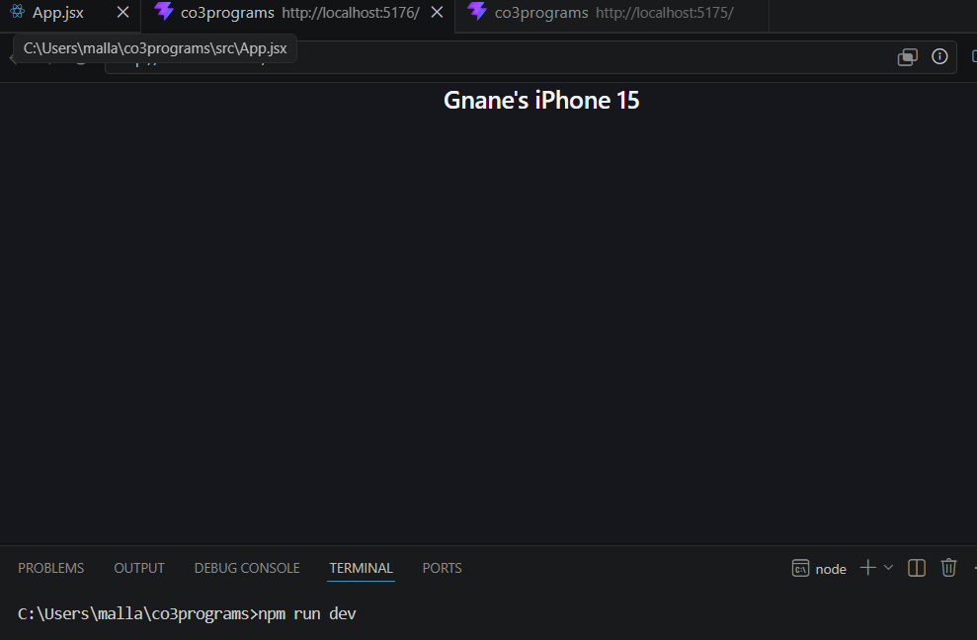

2.Props as Configuration Contract
CODE:
function Product(props) {
return (
<div>
<h2>{props.name}</h2>
<p>Price: ₹{props.price}</p>
</div>
);
}
function App() {
return (
<Product name="Laptop" price="55000" />
);
}
export default App;
OUTPUT:
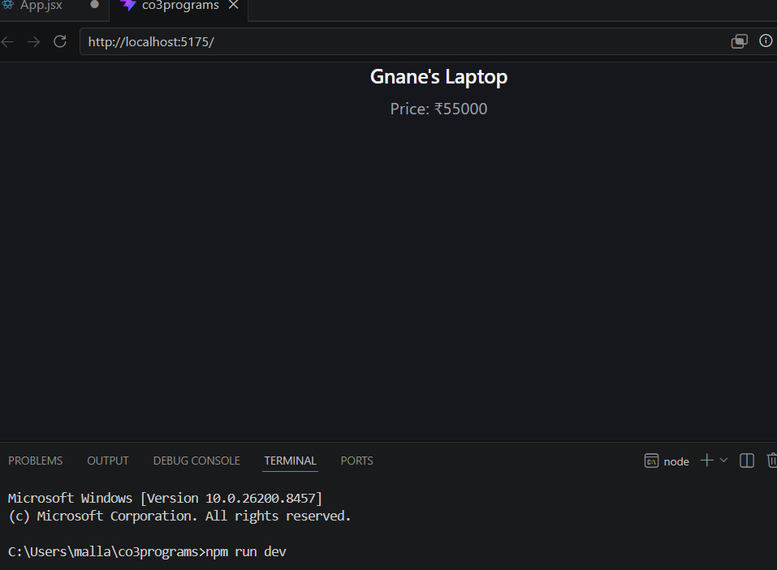

3.State as Dynamic Runtime
CODE:
import { useState } from "react";
function Cart() {
const [quantity, setQuantity] = useState(1);
return (
<div>
<h2>Quantity: {quantity}</h2>
<button onClick={() => setQuantity(quantity + 1)}>
Add More
</button>
</div>
);
}
export default Cart;
OUTPUT:
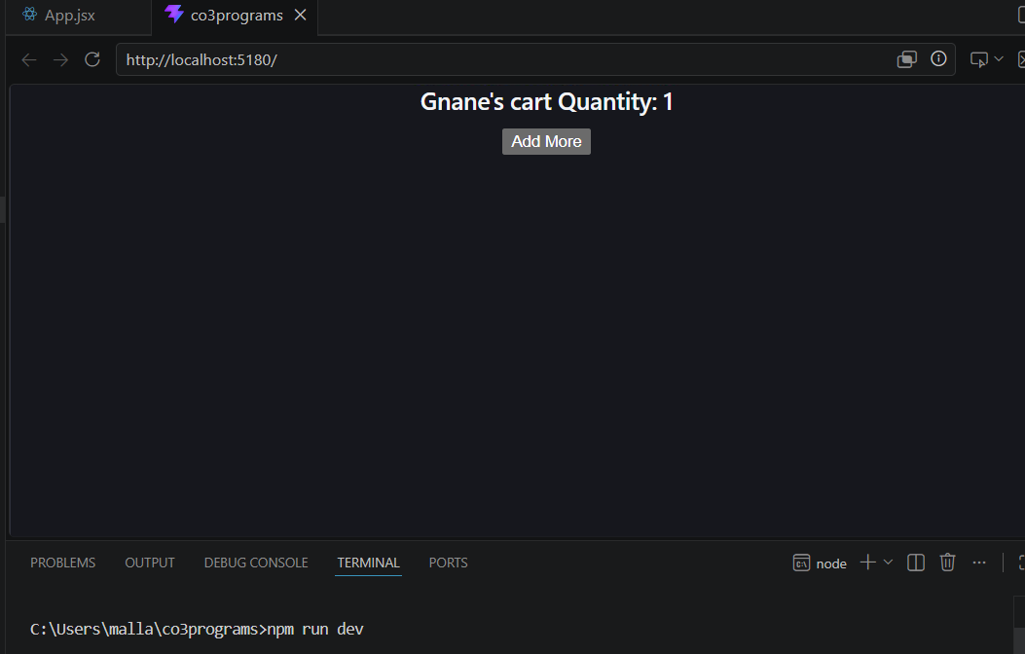

4.Props vs State
Ex:- Product with Dynamic likes
CODE:
import { useState } from "react";
function Product(props) {
const [likes, setLikes] = useState(0);
return (
<div>
<h2>{props.name}</h2>
<p>Likes: {likes}</p>
<button onClick={() => setLikes(likes + 1)}>
Like Product
</button>
</div>
);
}
function App() {
return <Product name="Headphones" />;
}
export default App;
OUTPUT:
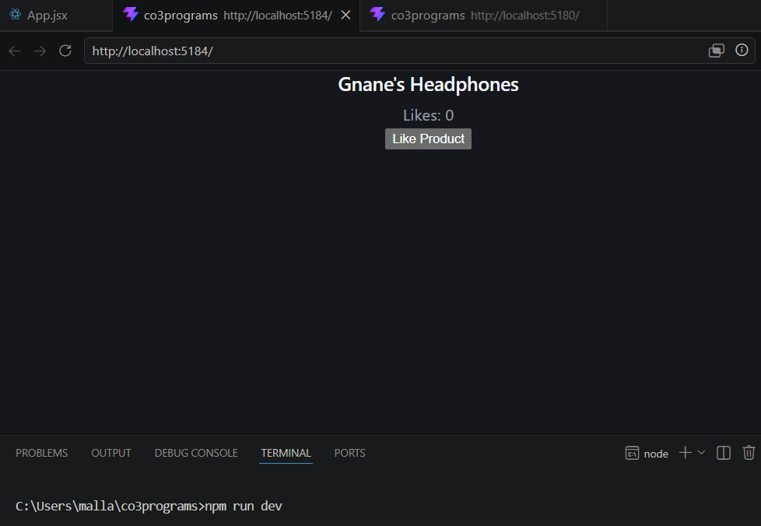

5. Side Effects using useEffect
Ex:- Fetch Product Data
CODE:
import { useEffect } from "react";
function ProductPage() {
useEffect(() => {
console.log("Fetching Product Details...");
}, []);
return <h1>Product Details</h1>;
}
export default ProductPage;
OUTPUT:

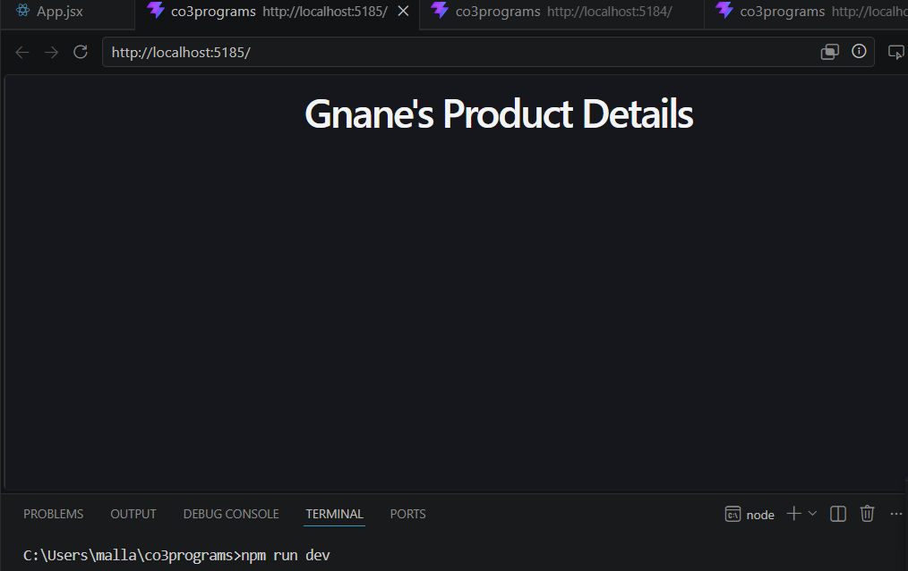

6. Hooks as Lifecycle Abstraction
Ex:- Product View Counter
CODE:
import { useEffect, useState } from "react";
function Product() {
const [views, setViews] = useState(0);
useEffect(() => {
setViews(views + 1);
}, []);
return <h2>Views: {views}</h2>;
}
export default Product;
OUTPUT:

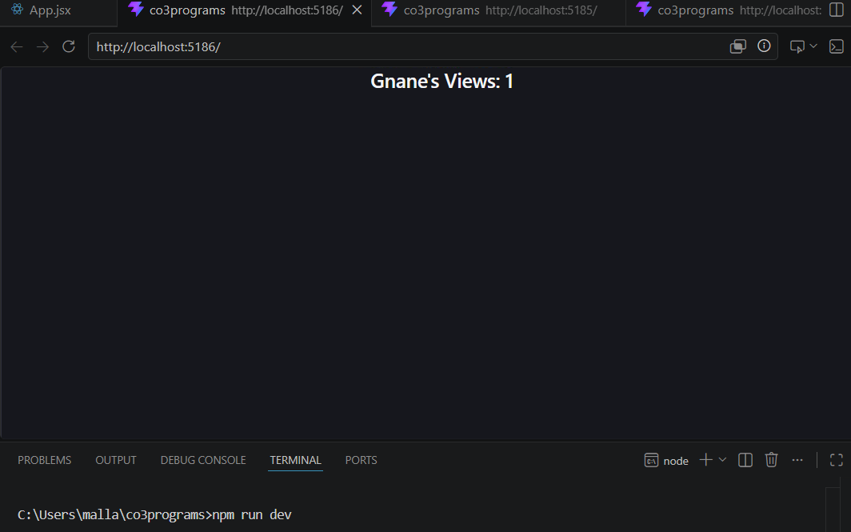

7. Reconciliation (Re-rendering)
Ex:- Cartimport { useState } from "react";
CODE:
function Cart() {
const [total, setTotal] = useState(1000);
return (
<div>
<h2>Total: ₹{total}</h2>
<button onClick={() => setTotal(total + 500)}>
Add Item
</button>
</div>
);
}
export default Cart;
OUTPUT:
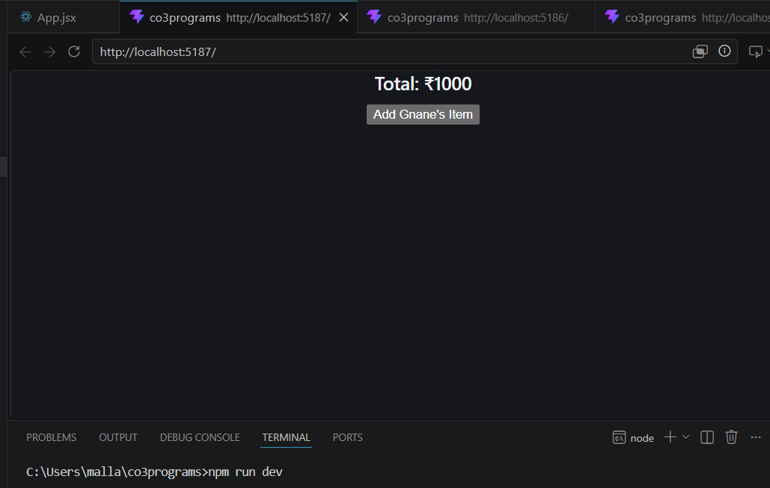

8. Controlled Component
Ex:- Search Bar
CODE:
import { useState } from "react";
function Search() {
const [text, setText] = useState("");
return (
<div>
<input
type="text"
value={text}
onChange={(e) => setText(e.target.value)}
placeholder="Search Product"
/>
<p>You searched: {text}</p>
</div>
);
}
export default Search;
OUTPUT:

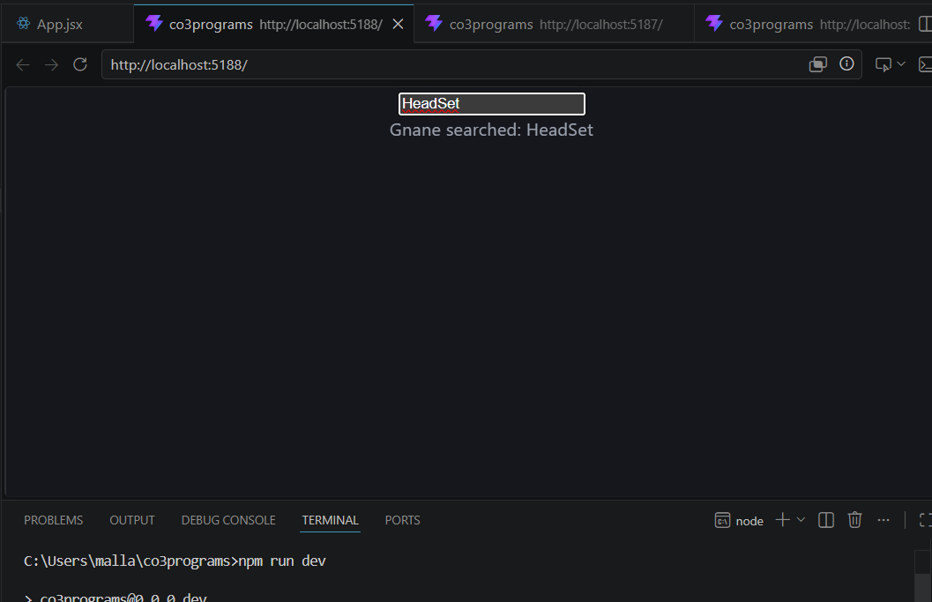

9. Uncontrolled Component
Ex:- Coupon Code Input
CODE:
import { useRef } from "react";
function Coupon() {
const inputRef = useRef();
function applyCoupon() {
alert(inputRef.current.value);
}
return (
<div>
<input type="text" ref={inputRef} />
<button onClick={applyCoupon}>
Apply Coupon
</button>
</div>
);
}

export default Coupon;
OUTPUT:

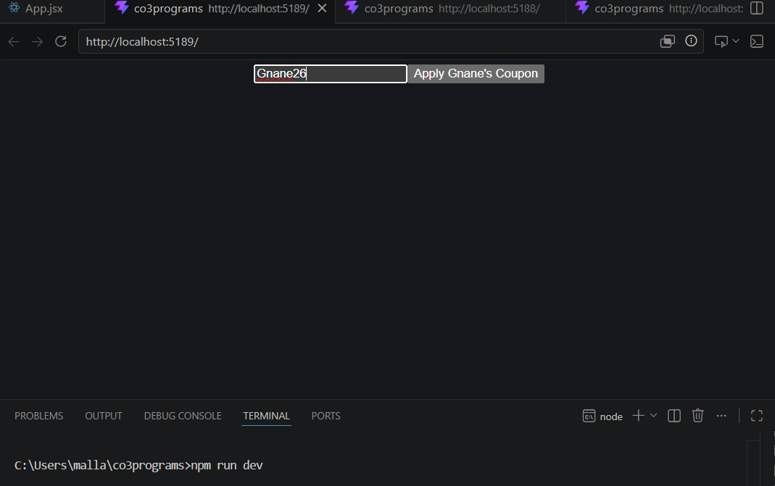

10. Component Composition
Ex:- Product Card Using Smaller Components
CODE:
function ProductName() {
return <h2>Smart Watch</h2>;
}
function ProductPrice() {
return <p>₹3000</p>;
}
function ProductCard() {
return (
<div>
<ProductName />
<ProductPrice />
</div>
);
}

export default ProductCard;
OUTPUT:

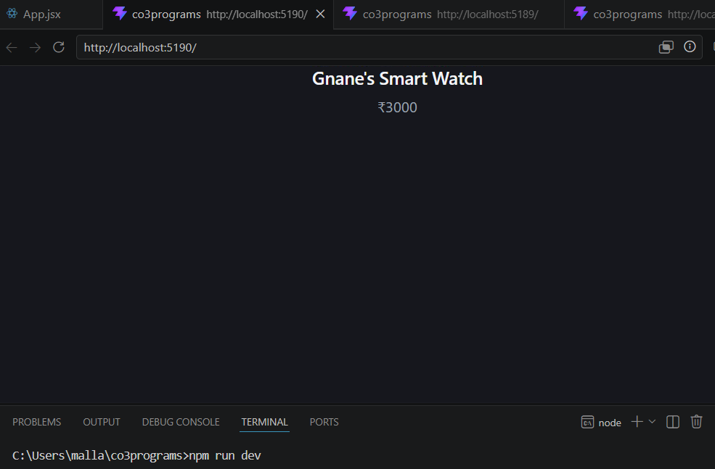

11. Reusable Components
Ex:- Reusable Button
CODE:
function Button(props) {
return (
<button>
{props.label}
</button>
);
}
function App() {
return (
<div>
<Button label="Buy Now" />
<Button label="Add to Cart" />
</div>
);
}
Export default App;
OUTPUT:

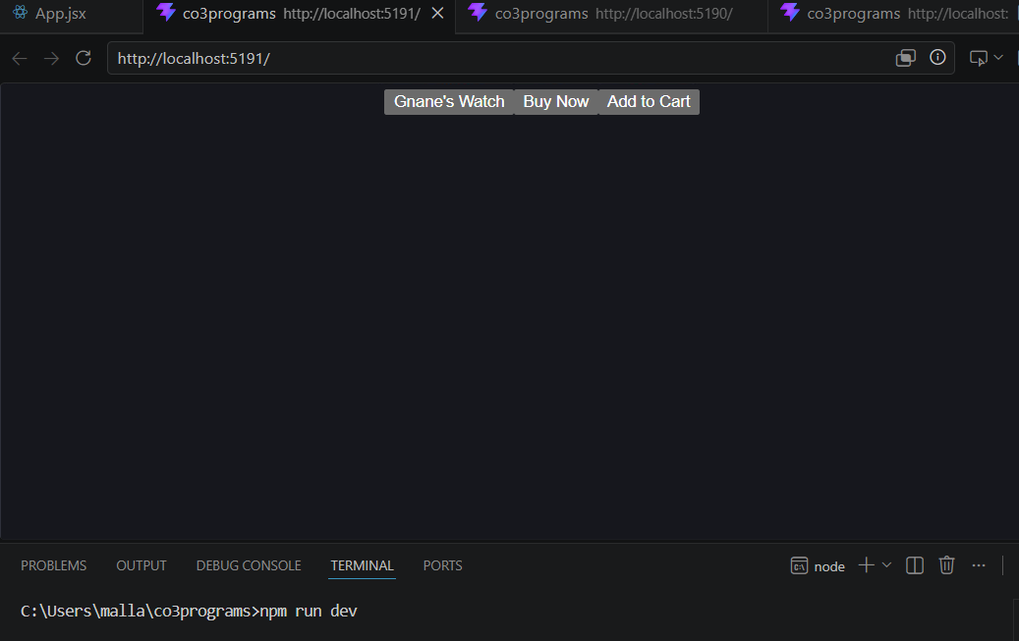

12. Event Handler Example
Ex:- Add to Cart
CODE:
function Product() {
function addToCart() {
alert("Product Added to Cart");
}
return (
<button onClick={addToCart}>
Add to Cart
</button>
);
}
export default Product;
OUTPUT:

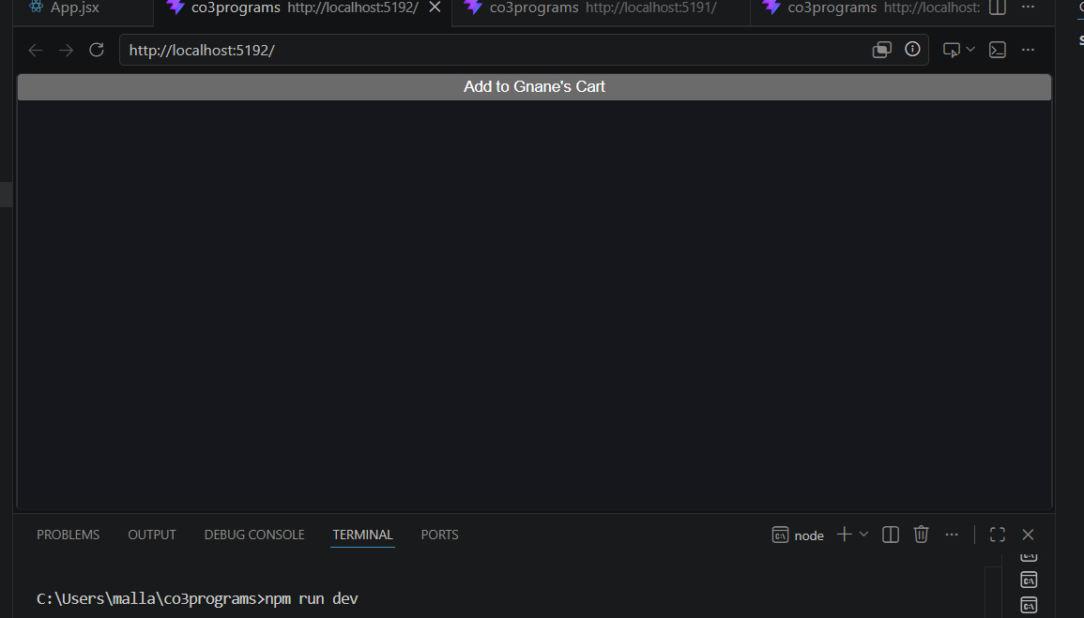

13. Children Props Example
Ex:- Product Card Layout
CODE:
function Card(props) {
return (
<div style={{border:"1px solid black", padding:"10px"}}>
{props.children}
</div>
);
}
function App() {
return (
<Card>
<h2>Shoes</h2>
<p>₹2000</p>
</Card>
);
}
Export default App;
OUTPUT:

